**Samir Bagga**

**CMO, L&T Technology Services Ltd**

Samir is the Chief Marketing Officer at engineering services major L&T Technology Services Limited. An international B2B professional based out of New Jersey with over 25 years of marketing experience for Global 1000 & SME corporations in the Americas, Europe and India, Samir has been instrumental in creating and executing initiatives comprising of customer intimacy programs, demand generation and influencer relationships.

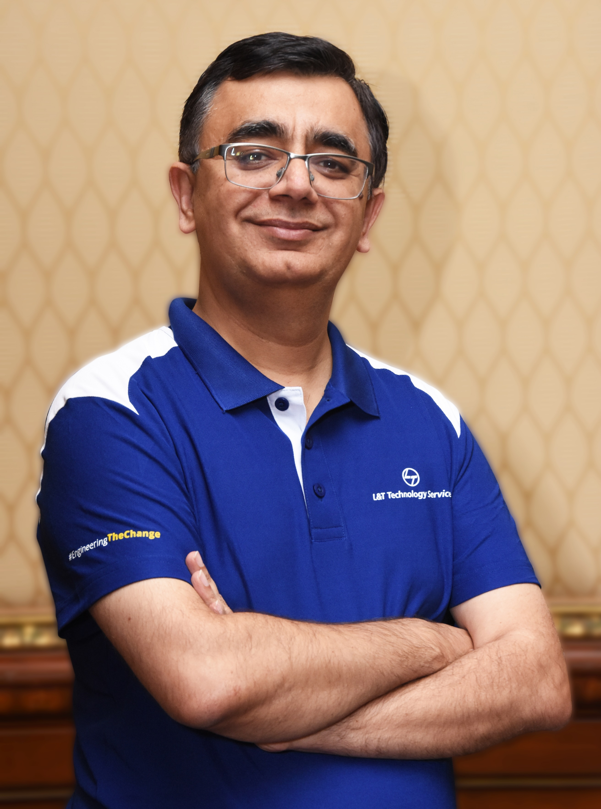

He has done extensive work on brand building through digital & web based events, advertising, conferences & seminars while working closely with C-suite and business leaders. At L&T Technology Services, Samir leads a high-power marketing & communications team which is directly responsible for building, influencing and generating significant top line and C-SAT growth for the company.

As CMO, Samir is part of the top management team that led L&T Technology Services through its Initial Public Offering (IPO) in India and successfully listed the company on the National Stock Exchange and the Bombay Stock Exchange.

Prior to joining the L&T Group, Samir worked with HCL Technologies as Vice President and Head of Marketing for the North American and European markets. He also led the marketing initiatives at Satyam for over a decade. Samir holds a Bachelor’s degree in Mechanical Engineering and a Master’s degree in Product Design & Communications from Indian Institute of Technology, Bombay, India.

**========**